Assignment-3

|  |  |
| --- | --- |
| Assignment Date | 26 october2022 |
| Student Name | ANBARAN ARIVUKOE. N |
| Student Roll Number | 913119104005 |
| Maximum Marks | 2 Marks |

# Question-1:

1. **Create a Bucket in IBM object storage.**

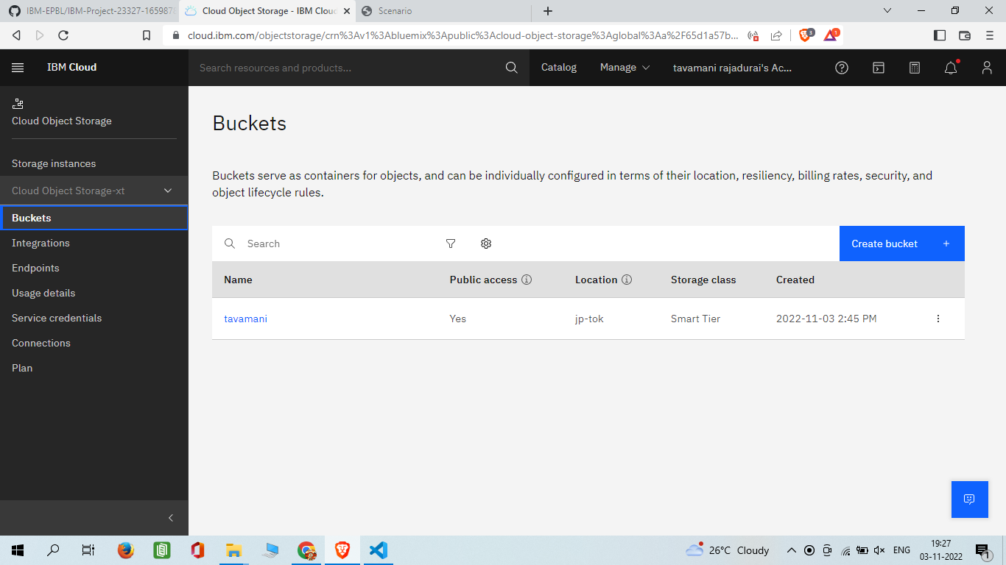

# Question-2:

1. **Upload an 5 images to ibm object storage and make it public. write html code to displayingall the 5 images.**

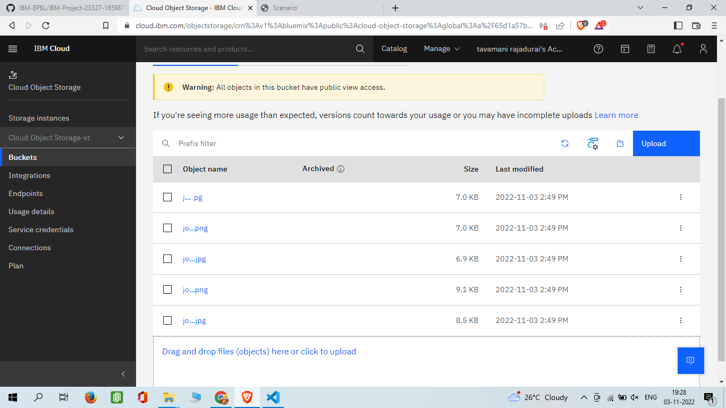

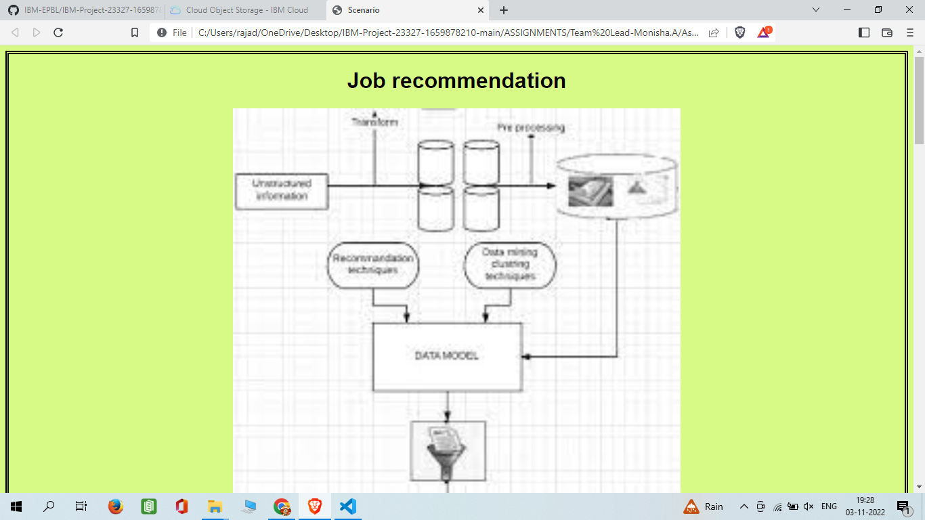

# Canadian scenario.html

<!DOCTYPE html>

<title>Canadian Scenario</title>

<head>

<style>

img{

display: block; margin-left: auto; margin-right: auto; border: aqua;

width: 50%;

}

</style>

</head>

<body style="background-color: aqua;">

<h1>CANADIAN SCENARIO</h1>

<img src=" [https://tavamani.s3.jp-tok.cloud-object-storage.appdomain.cloud/job.jpg"](http://s3.jp-tok.cloud-object-storage.appdomain.cloud/monisha24/img1.jpg) alt="amazon" style="width:50%" >

<br>

<img src="[https://tavamani.s3.jp-tok.cloud-object-storage.appdomain.cloud/job2.jpg"](http://s3.jp-tok.cloud-object-storage.appdomain.cloud/monisha24/img2.jpg) alt=" google"width="600"

height="600">

<br>

<img src=" [https://tavamani.s3.jp-tok.cloud-object-storage.appdomain.cloud/job3.jpg"](http://s3.jp-tok.cloud-object-storage.appdomain.cloud/monisha24/img3.jpg) alt="ibm"width="600" height="600">

<br>

<img src="[https://tavamani.s3.jp-tok.cloud-object-storage.appdomain.cloud/job4.jpg"](http://s3.jp-tok.cloud-object-storage.appdomain.cloud/monisha24/img4.jpg) alt="box" width="600" height="600">

<br>

<img src="[https://tavamani.s3.jp-tok.cloud-object-storage.appdomain.cloud/job5.jpg"](http://s3.jp-tok.cloud-object-storage.appdomain.cloud/monisha24/img5.jpg) alt="microsoft"width="600" height="600">

</body>

</html>

# Question-3:

1. **Upload a css page to the object storage and use the same page in your HTML code.**



# Canadian scenario styling.html:

<!DOCTYPE html>

<title>Canadian scenario</title>

<head>

<style> img{

display: block; margin-left: auto; margin-right: auto; border: aqua; width: 50%;

}

Body{

style="border:rgb(15, 15, 15); border-width:5px;

border-style:double;text-align: center;font-family: Arial, Helvetica, sans-serif; background-color:powderblue"

}

</style>

</head>

<body style="background-color: aqua;">

<h1>CANADIAN SCENARIO</h1>

<img src=" [https://tavamani.s3.jp-tok.cloud-object-storage.appdomain.cloud/job.jpg"](http://s3.jp-tok.cloud-object-storage.appdomain.cloud/monisha24/img1.jpg) alt="amazon" style="width:50%" >

<br>

<img src="[https://tavamani.s3.jp-tok.cloud-object-storage.appdomain.cloud/job2.jpg"](http://s3.jp-tok.cloud-object-storage.appdomain.cloud/monisha24/img2.jpg) alt=" google"width="600"

height="600">

<br>

<img src=" [https://tavamani.s3.jp-tok.cloud-object-storage.appdomain.cloud/job3.jpg"](http://s3.jp-tok.cloud-object-storage.appdomain.cloud/monisha24/img3.jpg) alt="ibm"width="600" height="600">

<br>

<img src="[https://tavamani.s3.jp-tok.cloud-object-storage.appdomain.cloud/job4.jpg"](http://s3.jp-tok.cloud-object-storage.appdomain.cloud/monisha24/img4.jpg) alt="box" width="600" height="600">

<br>

<img src="[https://tavamani.s3.jp-tok.cloud-object-storage.appdomain.cloud/job5.jpg"](http://s3.jp-tok.cloud-object-storage.appdomain.cloud/monisha24/img5.jpg) alt="microsoft"width="600" height="600">

</body>

</html>

# Style.css

Body{

style="border:rgb(15, 15, 15); border-width:5px;

border-style:double;text-align: center;font-family: Arial, Helvetica, sans-serif; background-color:powderblue"

}

# Question-4:

**Design a chatbot using IBM Watson assistant for hospital. Ex: User comes with query to know thebranches for that hospital in your city. Submit the web URL of that chat bot as a assignment.**

[https://web-](https://web-chat.global.assistant.watson.appdomain.cloud/preview.html?backgroundImageURL=https%3A%2F%2Fau-syd.assistant.watson.cloud.ibm.com%2Fpublic%2Fimages%2Fupx-dd023609-f951-4da6-a246-92943dc5e937%3A%3A4061dd95-6586-4768-bc5c-42f4c0759115&integrationID=2f598fa3-d76d-4766-b86f-92a28d85dae9&region=au-syd&serviceInstanceID=dd023609-f951-4da6-a246-92943dc5e937) [chat.global.assistant.watson.appdomain.cloud/preview.html?backgroundImageURL=https%3A%2F%](https://web-chat.global.assistant.watson.appdomain.cloud/preview.html?backgroundImageURL=https%3A%2F%2Fau-syd.assistant.watson.cloud.ibm.com%2Fpublic%2Fimages%2Fupx-dd023609-f951-4da6-a246-92943dc5e937%3A%3A4061dd95-6586-4768-bc5c-42f4c0759115&integrationID=2f598fa3-d76d-4766-b86f-92a28d85dae9&region=au-syd&serviceInstanceID=dd023609-f951-4da6-a246-92943dc5e937) [2Fau-syd.assistant.watson.cloud.ibm.com%2Fpublic%2Fimages%2Fupx-dd023609-f951-4da6-a246-](https://web-chat.global.assistant.watson.appdomain.cloud/preview.html?backgroundImageURL=https%3A%2F%2Fau-syd.assistant.watson.cloud.ibm.com%2Fpublic%2Fimages%2Fupx-dd023609-f951-4da6-a246-92943dc5e937%3A%3A4061dd95-6586-4768-bc5c-42f4c0759115&integrationID=2f598fa3-d76d-4766-b86f-92a28d85dae9&region=au-syd&serviceInstanceID=dd023609-f951-4da6-a246-92943dc5e937) [92943dc5e937%3A%3A4061dd95-6586-4768-bc5c-42f4c0759115&integrationID=2f598fa3-d76d-](https://web-chat.global.assistant.watson.appdomain.cloud/preview.html?backgroundImageURL=https%3A%2F%2Fau-syd.assistant.watson.cloud.ibm.com%2Fpublic%2Fimages%2Fupx-dd023609-f951-4da6-a246-92943dc5e937%3A%3A4061dd95-6586-4768-bc5c-42f4c0759115&integrationID=2f598fa3-d76d-4766-b86f-92a28d85dae9&region=au-syd&serviceInstanceID=dd023609-f951-4da6-a246-92943dc5e937) [4766-b86f-92a28d85dae9&region=au-syd&serviceInstanceID=dd023609-f951-4da6-a246-](https://web-chat.global.assistant.watson.appdomain.cloud/preview.html?backgroundImageURL=https%3A%2F%2Fau-syd.assistant.watson.cloud.ibm.com%2Fpublic%2Fimages%2Fupx-dd023609-f951-4da6-a246-92943dc5e937%3A%3A4061dd95-6586-4768-bc5c-42f4c0759115&integrationID=2f598fa3-d76d-4766-b86f-92a28d85dae9&region=au-syd&serviceInstanceID=dd023609-f951-4da6-a246-92943dc5e937) [92943dc5e937](https://web-chat.global.assistant.watson.appdomain.cloud/preview.html?backgroundImageURL=https%3A%2F%2Fau-syd.assistant.watson.cloud.ibm.com%2Fpublic%2Fimages%2Fupx-dd023609-f951-4da6-a246-92943dc5e937%3A%3A4061dd95-6586-4768-bc5c-42f4c0759115&integrationID=2f598fa3-d76d-4766-b86f-92a28d85dae9&region=au-syd&serviceInstanceID=dd023609-f951-4da6-a246-92943dc5e937)

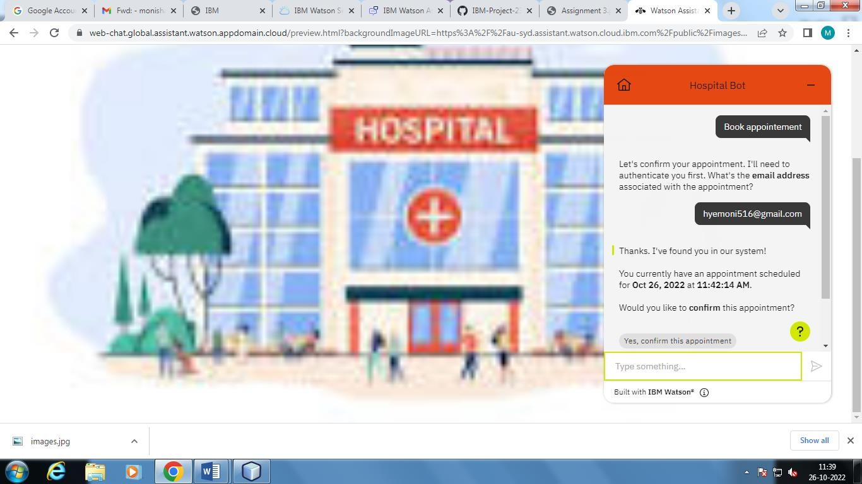

# Question-5

**5.Create Watson assistant service with 10 steps and use 3 conditions in it. Load that script inHTMLpage.**

<!DOCTYPE html>

<title>abc hospital</title>

<style>

body {

background: url(https://wallpaperaccess.com/full/1282794.jpg) no-repeat center center fixed;

-webkit-background-size: cover;

-moz-background-size: cover;

-o-background-size: cover; background-size: cover

}

</style>

<body>

<script> <script> window.watsonAssistantChatOptions = { integrationID: "2f598fa3-d76d-4766-b86f- 92a28d85dae9", // The ID of this integration.

region: "au-syd", // The region your integration is hosted in. serviceInstanceID: "dd023609-f951-4da6- a246-92943dc5e937", // The ID of your service instance.

onLoad: function(instance) { instance.render(); }

};

setTimeout(function(){

const t=document.createElement('script'); t.src="https://web- chat.global.assistant.watson.appdomain.cl oud/versions/" + (window.watsonAssistantChatOptions.clie ntVersion || 'latest') + "/WatsonAssistantChatEntry.js"; document.head.appendChild(t);

});

</script></script>

</body>

</html>

